Addicted to your iPhone?
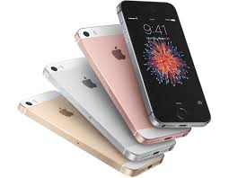
Why do we love technology so much? What is it about that takes our precious time and glues us to an electronic screen for so long? Mobile phones have become a common part of everyday life and it seems that getting separated from them can have psychological effects especially on iPhone users. When your phone’s at one per cent and you’re freaking out, this could be a sign of excessive attachment to something that’s literally inanimate.
The latest study by researchers from the University of Missouri has shown that phone users suffer from physiological impairment if they’re deprived of access to their cherished devices. Russell Clayton, the author of the study, said that „iPhones are capable of becoming an extension of ourselves such that when separated, we experience a lessening of ‘self’ and a negative physiological state.” He also discovered a considerable increase in blood pressure, anxiety and heart rate. If you want to check if iPhone addiction is real, watch the video to see how some girls react if they’re not around their smartphones.
It goes without saying that texting, using social networking websites to touch base with friends is like replacing quality with quantity. Will that help you develop proper relationships or give you more acquaintances rather than trusted friends? I won’t answer that question… It’s up to you.
freak out – wychodzić z siebie, paranoicznie bać się
excessive – nadmierny
attachment – przywiązanie (do czegoś)
inanimate – nieożywiony, martwy (o przedmiotach)
impairment – upośledzenie
deprive of – pozbawić (kogoś czegoś)
cherished – ulubiony, ukochany
capable – potrafiący
lessening – zmniejszenie się
anxiety – niepokój, obawa
touch base with – pogadać z kimś
proper – właściwy, odpowiedni
acquaintance – znajomy

1. According to the author texting and using social networking websites will help you develop proper relationships.
a) true b) false
2. Mobile phones have become a common part of everyday life.
a) true b) false
3. Leaving a mobile phone does not affect your physiological state.
a) true b) false

